Mappings
Geometrical Representation:
To draw curve of complex variable $\left(x,y\right)$we take two axes i.e., one real axis and the other imaginary axis. A number of points $\left(x,y\right)$ are plotted on $z$-plane, by taking different value of $z$ (different value of x and y). The curve C is drawn by joining the plotted points. The diagram obtained is called Argand diagram.

Transformation:
For every point $\left(x,y\right)$ in the z-plane, the relation $w=f(z)$ defines a corresponding point $\left(u,v\right)$ in the $w$-plane. We call this “transformation or mapping of $z$-plane into $w$-plane”. If a point $z_{0}$ maps into the point$w_{0}$, $w_{0}$is known as the image of${ z}_{0}$.
If the point $P(x,y)$ moves along a curve C in $z$-plane, the point $P^{'}(u,v)$ will move along a corresponding curve $C_{1}$ in the $w$-plane. We, then, say that a curve C in the $z$-plane is mapped into the corresponding curve $C_{1}$ in the $w$- plane by the relation $w=f(z)$.

Translation, Rotation and reflection are the standard transformations. Terms such as translation, rotation and reflection are used to convey dominant geometric characteristics of certain mappings.

Translation
$w=z+C$,
where,
$$C=a+ib$$
$$z=x+iy$$
$$w=u+iv$$
Hence, $u+iv=x+iy+a+ib$
So, $u=x+a$ and $v=y+b$
$x=u-a$ and $y=v-b$
On substituting the values of $x$ and $y$in the equation of the curve to be transformed we get the equation of the image in the $w$-pane.
As an example the mapping $w=z+1$ where $z=x+iy$, can be thought of as a translation of each point of $z$ one unit to the right.
Example:
Let the rectangular region $R$ in z-plane which is bounded by the lines
$x=0, y=0, x=2, y=1.$
Determine the region $R'$ of the w-plane into which $R$ is mapped under the transformation
$w=z+1$.

Solution:  Given $w=z+1$  or, $u+iv=\left(x+1\right)+iy$.  Hence $u=x+1$ and $v=y$.  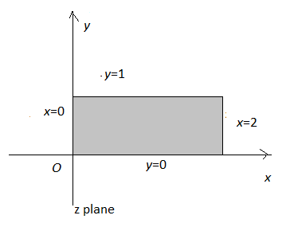 | when $x=0, u=1$,  $y=0, v=0$  $x=2, u=3$,  $y=1, v=1$  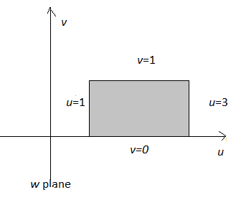  u
Rotation:
The mapping $w=iz$ where $z=re^{iθ}$ can be thought of as a rotation of the radius vector for each non-zero point z through a right angle about the origin in the counter clock wise direction.

Example:
Let the rectangular region $R$ in z-plane which is bounded by the lines
$x=0, y=0, x=2, y=1.$
Determine the region $R'$ of the w-plane into which $R$ is mapped under the transformation
$w=iz$.
Solution:  Given $w=iz$  or, $u+iv=-y+ix$.  Hence $u=-y$ and $v=x$.  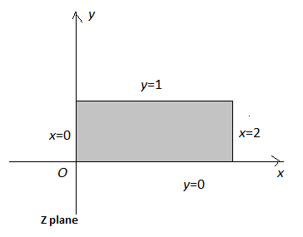 | when $x=0, v=0$,  $y=0, u=0$  $x=2, v=2$,  $y=1, u=-1$  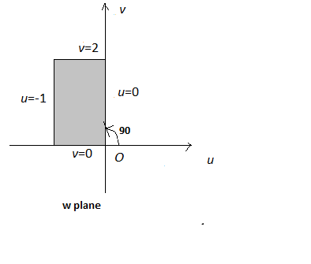
Reflection:
The mapping $w=\overline{z}$ transforms each point of $z=x+iy$ into its reflection in the real axis.
Example:
Let the rectangular region $R$ in z-plane which is bounded by the lines
$x=0, y=0, x=2, y=1.$
Determine the region $R'$ of the w-plane into which $R$ is mapped under the transformation
$w=\overline{z}$ .
Solution:
Given $w=\overline{z}$  or, $u+iv=x-iy$.  Hence $u=x$ and $v=-y$. | when $x=0, u=0$,  $y=0, v=0$  $x=2, u=2$,  $y=1, v=-1$
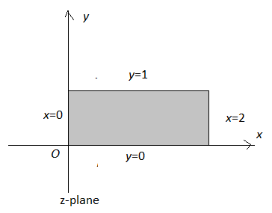 | 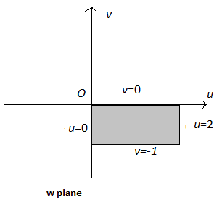

Example:
Given triangle T in the z-plane with vertices at $-1+2i, 1-2i and 1+2i.$ Determine the triangle $T'$ of the w-plane into which $T$ is mapped under the transformation $w=\sqrt{2}e^{\frac{πi}{4}}z$.
Solution:
Given $w=\sqrt{2}e^{\frac{πi}{4}}z=\left(1+i\right)\left(x+iy\right)$  or, $u+iv=\left(x-y\right)+i\left(x+y\right)$.  Hence $u=x-y$ and $v=x+y$.  When  $$x=1,$$  $$y=2$$  $$y=-2x$$  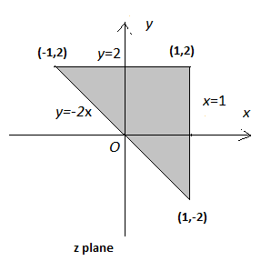 | The vertices of the triangle are  $-1+2i, 1-2i,1+2i.$ Hence the sides are  $x=1,$ $y=2$ and $y=-2x.$  $$u=1-y, v=1+y => u+v=2$$  $$u=x-2, v=x+2 => u-v=-4$$  $$u=3x, v=-x => u+3v=0$$  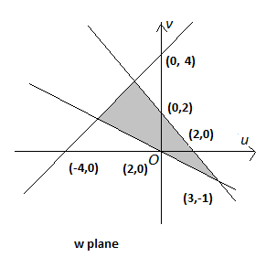

Exercise Set
- Let the rectangular region $R$ in z-plane which is bounded by the lines
$x=2, y=0, x=5 and y=4.$ Determine the region $R'$ of the w-plane into which $R$ is mapped under the following transformations:
(i) $w=3z-(2+3i)$, (ii) $w=\frac{1}{2}e^{\frac{πi}{2}}z+2i$,
(iii) $w=\sqrt{2}e^{\frac{πi}{4}}z-\left(1-i\right)$, (iv) ${w=e}^{iπ}z+3+i$,
(v) $w=\frac{1}{\sqrt{2}}e^{\frac{πi}{4}}z+1-3i$.

2. Given triangle T in the z -plane with vertices at $1, 1-3i and 3-i.$ Determine the triangle $T'$ of the w-plane into which $T$ is mapped under the following transformations:
(i) $w=3z+1-3i$, (ii) $w=iz+3+2i$,
(iii) $w=\left(1+2i\right)z-i$, (iv) $w=\frac{1}{2}e^{\frac{πi}{2}}z-4.$

